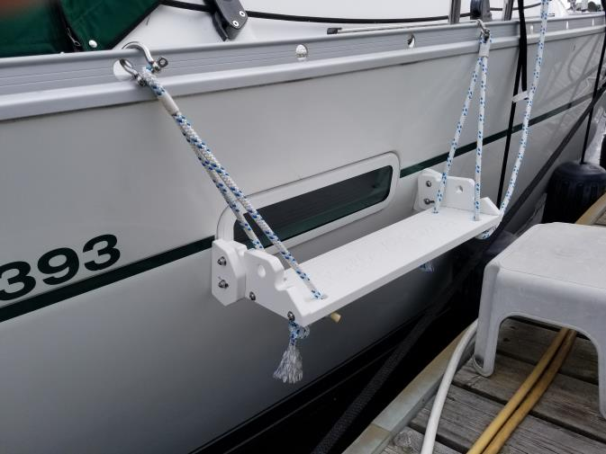
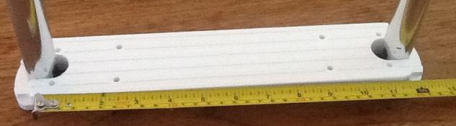
The Boarding new Step

Who are our clients?
In the beginning, we had two retail distributors. Direct sales were via word of mouth and occasionally, eBay.
Most of you customers were American, but there were also a couple of Australians and Brits - actually the Channel Islands!
Since launching the website, a majority of you are Americans, with Texas, Florida, California and Delaware figuring strongly. Canadians are mainly from Ontario and Quebec.

What do you buy?
Our most popular product is definitely the Boarding Treads, followed by the Binox Holders and the Wine Bottle Holder.
What kind of boats do you have? An informal survey suggests that you are about three-quarter sailors and the rest motor boaters. You have boats ranging from 19 feet to 53 feet.

Your experiences
Next issue, we'll share a bunch of customer stories about their custom installations, reviews and travels.

Apropos Marine
Essential Cockpit Accessories

Apropos of Boats...
Back in 2007, I approached my favourite chandlery, to see if my newly acquired plastics skills (high-end accessories for high end parrots and owners!) could be used to make boat accessories. The owner handled me a drink holder and said "Can you make this cheap?"
This started the slide on the slippery slope of CNC machining of marine grade plastic. There seemed to be no end to the challenges - sourcing the plastic and begging design and machine time from plastics fabricators. One unexpected hurdle was learning the characteristics of the plastic itself - how it flexed and expanded. For example if the hooks were too thick, they wouldn't flex - too thin and they would snap.

Are we ... apropos?

What else is new?
1. An icebox/frig kit to keep cold stuff like milk and beer from rolling around, and food from getting soggy. Now listed on the website!
2. A snap on cockpit table mounted on the pedestal guard.
3. Do-it-yourself hook kits to make flag pole holders, stanchion mounted boom covers, winch handle holders, anchor chain tie downs and spinnaker pole supports.
+ spinnaker pole storage rings
+ dock line holders
+ anchor hold-downs
For your info, we have our regular hooks (for instrument mounts and drink holders) available in several sizes: 7/8", 1", 1 1/4" and 23mm (this size is common on European boats, but very few accessories are available).
Contact us
ralph@aproposmarine.com
(514) 952-4179

Apropos is an interesting word - it means "with regard to ...” and a second, related definition meaning - appropriate. In French, it has about the same meanings.
While we try to make products that are appropriate for the needs of fellow boaters, most of our products started as solutions to our personal needs and annoyances.
A case in point is the boat treads. For over 20 years, we endured the pain of climbing slippery, narrow stainless tubes when swimming. I couldn't bring myself to drill and mount an expensive teak tread that would have to be maintained and replaced. Originally, we hoped for a one-size-fits-all tread. That didn't work, so we have a number of lengths for 7/8" and 1" tubes. We also receive a huge number of requests for custom solutions for specific tread/ladder situations. These days, your Internet orders frequently open a Q/A dialogue that ends in confirmation that the treads will work. This definitely ain't Amazon, but it's Apropos!

Universal Chart plotter Mount
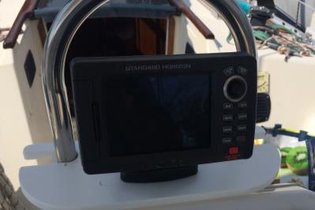
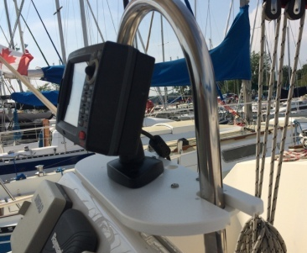
This Mount provides an economical, easy - install alternative to large instrument pods and huge holes in your cabin. The Mount is designed to fit 1" diameter pedestal guard tubing (1.25" tubing also available) found on the majority of wheel-equipped sailboats. The unique sliding fork (patent application in progress) accommodates pedestal tube spacing from 9.5" to 12" centres.

Different treads
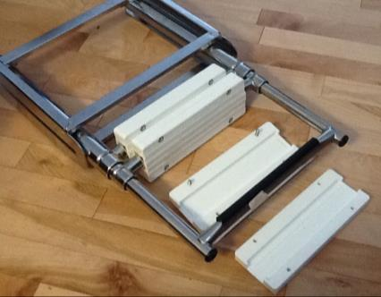
A number of inquiries have come in from boat owners with newer boats, often with boarding platforms and telescopic ladders. This spring, we started designing to cover this style of ladder -literally. These offshore-made ladders feature a squashed 1" stainless rung about 7" long, covered with molded black plastic about 1 1/2" wide. So it's better than a bare rung but still narrow and HOT. They are all remarkably similar, with only a small variation in the length of the black plastic tread. Our design is basically a clamshell, enclosing the existing tread and then bolted together. We came up with tweaks that allow the owners to trim the treads with a penknife and install with only a screw driver! After about 9 months of hard use, they are like new.

Not a tread, but a Step
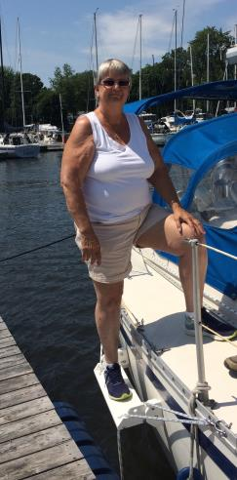
Getting on (or off) boats is seldom easy. Newer, larger boats have freeboards of 3 feet or more. My friend Geof says the limiting age factor for sailing is ones capacity to jump from a moving boat onto a dock. The Boarding Step is designed to reduce the shock.
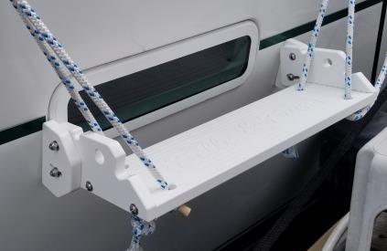
It features a 20" nonslip slab of 3/4" Seaboard, 6" wide with a 2" "kick-space" to the hull. It rests against the hull on 2 end plates, each with an adjuster plate to align flat with the hull's shape. The Boarding Step attaches with rope loops, with snaps shackles which in turn hooked to holes in the toe rail.
Boarding Step on a Beneteau 393
It's height adjustable, easy to reposition and makes an attractive dockside boarding step that can be easily stowed and taken with you. It can be positioned anywhere along the toe rail - in the lifeline gate or not. And it's nearly $200 cheaper than that very nice, fixed step made by a famous company. Oh yes, and you can have your boat's name engraved in the nonskid!

Treads for reverse transoms
The one complaint we have had about our treads are that they don't work well with angled ladders. I had the same complaint before I installed the swim platform and new ladder on Coup de Vent. We are prototyping a design for ladders on boats with a 20 to 55 degree reverse transom. Since a sloped ladder is more like a stair, we’re considering a much wider step – up to six inches. We'd appreciate hearing from potential customers...

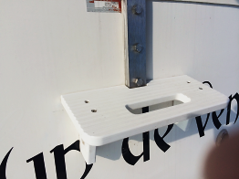
Transom Step
This goes with the Swim Platform on Coup de Vent, using the holes from the old ladder. It turned out very nicely, has a handhold and doubles as a comfortable seat. Since the angle is 20 degrees, It could be a stand - off mounting point for ladders on reverse transoms ...

Coup de Vent's Swim Platform
Swim Platform? No ladder? Heresy! Not really. If you are interested the story can be found at the Jeanneau Owners site:
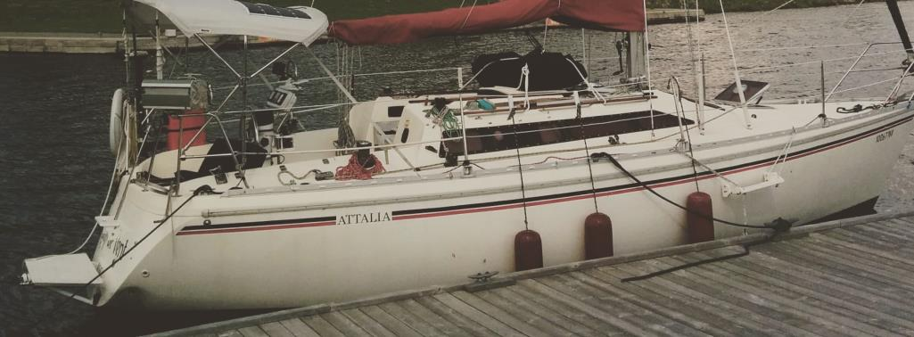
http://www.jeanneau-owners.com/hintsandtips/boardingplatform.html
Cradle Pads
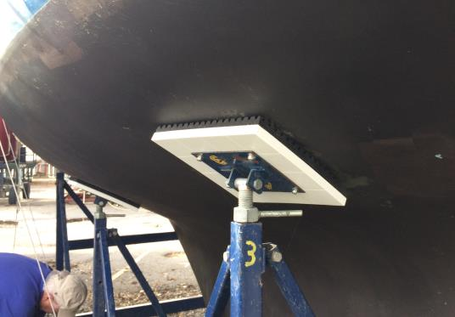
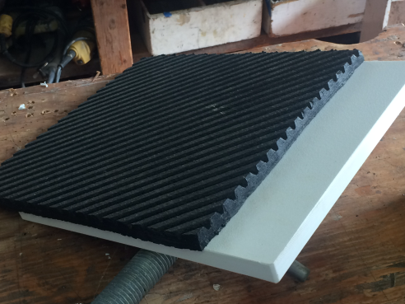
In denial about summer ending? These 3/4", 12" X 12" Seaboard slabs eliminate the need to replace plywood and carpet squares every 2-3 years. The rubber is 5/8" recycled tires, used on outdoor stairs and gyms. Stainless lag bolts and washers included. Nothing's permanent, but we are estimating their lifespan to be least15 years. They are not on the website yet, but they sell for $160 CDN for a set of 4, shipping extra.

